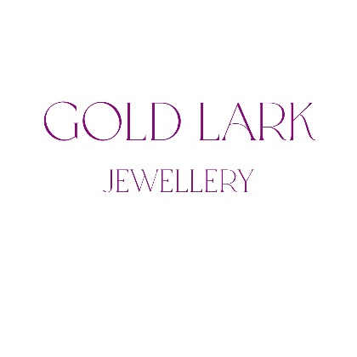
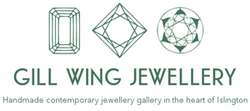


D U A L I T Y
The Association for Contemporary Jewellery
Gill Wing Jewellery X Gold Lark Jewellery

ACJ 2025 Members’ Show - application form
You may expand each box if needed. This form has 2 pages, again you may extend if needed.

Name
Email
Phone number/s
Website
Social media links e.g. Instagram, LinkedIn
Postal address
Address for return of work
Number of photos sent
Preference of gallery to show with | Gill Wing / Gold Lark / either gallery (please note that the galleries will make the final decision based on the curation.)
Instagram Takeover | There is a chance to win an Instagram Takeover for a free spot in the exhibition, if your work is selected. The guidelines will be sent to the winner/s and we will select people based on their existing Instagram profile. Would you like to be considered? YES / NO
Terms | I agree to ACJ’s published terms and conditions for this exhibition YES / NO

Statement: how does your work relate to the theme Duality?
A short statement of a maximum 150-word count, to be use in publicity.

Photos:
Following these instructions carefully saves our team a lot of time. Unlabelled photos will not be used.
- Please submit one image of each of your 1 - 6 pairs of earrings (either a completed piece or a design)
- The submitted images should be 72dpi please, not large files at this stage. 300x600 pixels. If you are selected you will be required to send higher res images.
- Image files – please title them with: your first name, family name and consecutive numbers e.g. – John_Smith_01, John_Smith_02
- If the photographer is not yourself add the photo credit (e.g. John_Smith_01_Photocredit_Jane Smith)

Please note that only word docs will be accepted.

Details of photos (maximum 6 photos)
Image label | Title of piece/s | Materials & techniques | Description (if you feel more detail is needed) | Dimensions in cm | Year made or hallmark date | Maker’s price *
eg John_Smith_01

*Maker’s price is what you expect to receive if the piece is sold, in £ sterling / GBP. The markup for both galleries is between x2 and x3 depending on the product. You can see examples of work/jewellers they represent here - https://gillwingjewellery.com/ and here -http://www.kathlibbertjewellery.co.uk/index.htm

Save this form with your name eg John_Smith_Unity (reminder, save as a .doc or .docx file)
Apply: Please send your images and your application form via We Transfer to exhibitions@acj.org.uk with the subject title “ACJ Duality”
Deadline Thursday 23rd January 2025 at midnight.

